CTF WRITEUP TASK 1 OWASP & MULEARN KERALA

CTF Name: Hack The Box

Challenge Name: Meow

Category: Privilege Escalation, Nmap

Date Solved:12-07-2025

Author: Sunny Abraham Mathew

1. Enumeration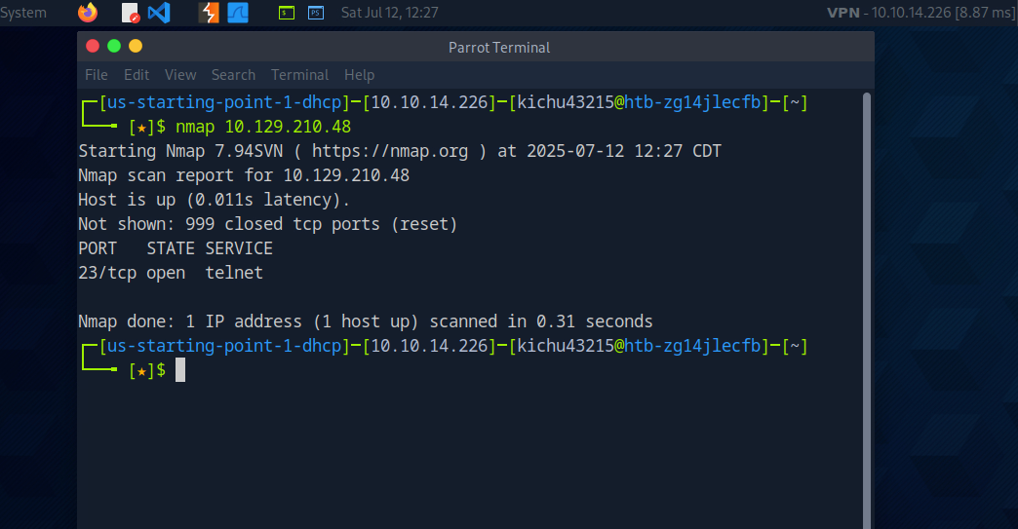

Started a Nmap scanned in the target ip and found out that port 23 was open. Which made me explore more about it.

2.Port Probing

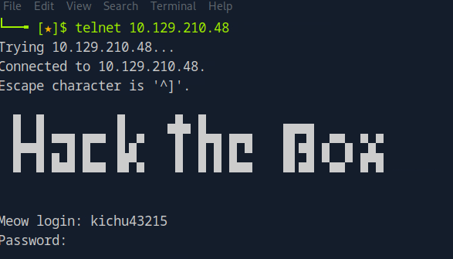

Scanned the particular port which led to a login page.  
3.Credential Based Access

Tried to login using given Credential which didn’t work out.

4.Root Login Exploitation

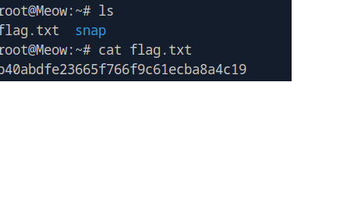

Got the root access and which indeed led me to the flag.